Chepstow House

An analysis of reoffending rates

Women are much less likely to reoffend when they engage with Chepstow House.

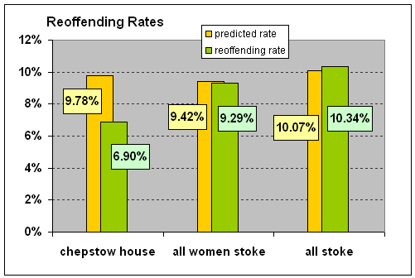

Women who engaged with Chepstow House through 2011 and 2012 had a much reduced reoffending rate compared to all female offenders on probation in Stoke, and all offenders (male or female) in Stoke in the same period.

The predicted rate is calculated using offender characteristics and shows the make-up of women at Chepstow House is largely the same as those on the probation caseload in Stoke in general.

Despite this, the reoffending rate of women at Chepstow House (6.9%) is much lower than the Stoke average (10.3%) and is 29% lower than its own predicted rate of 9%.

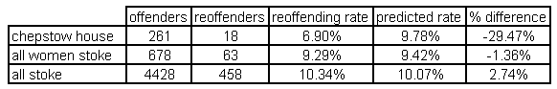

Data source: 209 individuals who engaged with Chepstow House between 2010 and 2012 were matched to the MoJ local adult reoffending stats, April 2011 to Setpember 2012. 105 were successfully matched - a match rate of 50%. These 105 women appeared on the MoJ reoffending statistics on 261 occasions. Any reoffending that took place before the start of engagement with Chepstow House was not included, but any reoffending that took place after engagement was.

