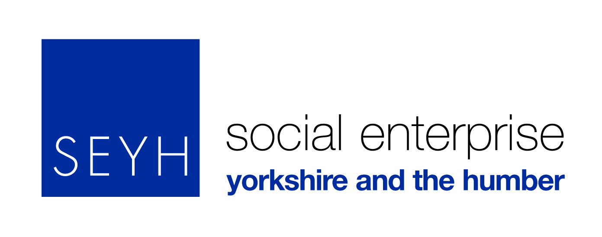
For Immediate Release
October 4th 2013

SEYH Award Winners 2013

Yorkshire and the Humber’s finest social businesses of 2013 have been chosen, these organisations combine the best of enterprise with a commitment to a social mission to aid local communities.

Social Enterprise Yorkshire and the Humber (SEYH) the Regional network organisation for Yorkshire and the Humber is pleased to announce our award winners for 2013. The awards were presented at the SEYH Awards Gala Dinner on Thursday 3rd October at Victoria Hall in Keighley

The SEYH Award Winners for 2011 are:
Start-up of the Year: Enabled Works
Social Impact of the Year: Key Changes - Unlocking Women's Potential
Social Entrepreneur of the Year: Darren Padgett (Team Activ)
Social Enterprise of the Year: Disability Action Yorkshire

Enabled Works Ltd was formed after the withdrawal of government funding for disabled workers as a ‘not for profit’ social enterprise workers Co-operative owned and run entirely by its own disabled workforce who are worker /owners. Enabled Works are employing, training and rehabilitating disabled people in a self sustaining work environment. Enabled Works services include Pick and Pack, Distribution, electro and mechanical works and fulfilment and mailing services.

Tina Brown MBE, Enabled Works Director, said that “Enabled Works is very proud of what we have achieved together and it is very pleasing to be recognised as leaders in our field. We hope that many other disabled people in the region will follow in our footsteps.”

Key Changes supports women in the criminal justice system with the aim of successful resettlement whilst reducing reoffending. It does so through individual aims for the women, including accommodation, skills for employment, and issues surrounding finance and benefits. The long-term social aim of the organisation is to set up a business enterprise which will provide accredited beauty and nails training to women.

Michelle Nicholson, Managing Director of Key Changes, said ‘Winning an award like this would not be possible without the commitment of our great team. It is a testament to their professionalism that our women receive a service that helps them to make major changes in their lives, supporting them to remove their personal barriers.”

Darren Padgett is Founder of Team Activ which is a life changing organisation which provides a range of physical activity and sport for Yorkshire schools, businesses and communities. Services in schools include inter-school tournaments, after school sport clubs, teacher training and advice.

Darren said “It is fantastic to receive an award judged by your peers, but at the same time a lot to live up to. I just wish there was room to put on the names of all of Team Activ as without their efforts this year I would have achieved nothing!”

Disability Action Yorkshire provides residential care for younger adults with physical disabilities, homecare, training for adults with disabilities in the skills required for employment, holiday accommodation, has an enterprise selling pre-used furniture which is linked to the training service .

Jackie Snape, Chief Executive of Disability Action Yorkshire, said ‘“Winning this award celebrates our unique work with Disabled People combining enterprise with social need, recently we have had a considerable growth in our services with the new furniture enterprise and holiday accommodation which I am glad has been recognised with this award.”

Alex Sobel General Manager of SEYH said ‘The quality and strength of applicants was amazing, the winners are doing truly exceptional work employing local people, driving enterprise and changing lives with truly inspirational work.’

SEYH Awards were sponsored by The Key Fund
New Start Social Enterprise of the Year sponsored by Confianza
Social Impact of the Year sponsored by Unity Trust Bank
Social Entrepreneur of the Year sponsored by ESP Projects
Social Enterprise of the Year sponsored by Key Fund

Notes for Editors
- Photographs are available on request
- Contact details for individual award winners are available on request
- SEYH Ltd is the regional network body for social enterprise in Yorkshire and the Humber
- Alex Sobel SEYH Manager is based at Ebor Court, Skinner St, Leeds, LS1 4ND 0113 3731762 or alex.sobel@seyh.org.uk

