Data extraction regarding experiences of trauma and abuse among offenders

This date is extracted from a study into alcohol needs compared to drug needs, within the probation service in 2004.
The data was extracted from the OASYS database using samples with completed OASYS assessments. 121 records were extracted with a proportion of roughly 1/3 women to 2/3 men. The selection was made by taking surnames alphabetically and then taking the first name that had a sufficiently completed record, alternating from alphabetical to reverse alphabetical until a sufficient sample of men and women had been obtained.
The data set included gender, age, ethnicity, offending behaviour, OASys drug score, OASYS alcohol score, qualified assessment of treatment need using Models of Care tier system, and a set of needs including accommodation, education training and employment, social skills, mental health, physical health, and whether there was a history of trauma, particularly abuse, suffered by the client. A complex needs score was synthesised from these needs.
The main purpose of the study was to demonstrate that there was a high prevalence of alcohol treatment needs not being met, while resources were disproportionately directed towards drug treatment. That was amply demonstrated by the study and resulted in some policy change to improve attention to alcohol treatment.
The study strikingly revealed the significance of complex needs, particularly in raising awareness of the impact of trauma, especially childhood abuse, among offenders. Sorting the data according to multiple needs and intensity of alcohol and other drug use, it became clear that with increasing substance use and offending, other needs also increased and it became much more likely that trauma and abuse would be detected.
Clients with complex needs had significantly elevated treatment needs that required correspondingly increased level of resources, which for some cohorts would be equivalent to a whole treatment tier level.
The number of women in the sample with OASYS drug scores greater than 4 and history of trauma and abuse was disproportionately high, as was the total number of both women and men who had suffered abuse. It therefore appears that experiences of trauma are likely to be more prevalent among offenders in general than in the general population, and where there are a series of complex needs it is even more likely that this factor needs to be addressed, and more proportionate resources devoted to addressing these needs among women.
Some of the data pertaining to experiences of trauma and abuse, related to complex needs is depicted in the following charts:
The numbers of offenders with obvious history of trauma especially abuse is astonishingly high, and disproportionately so for women.
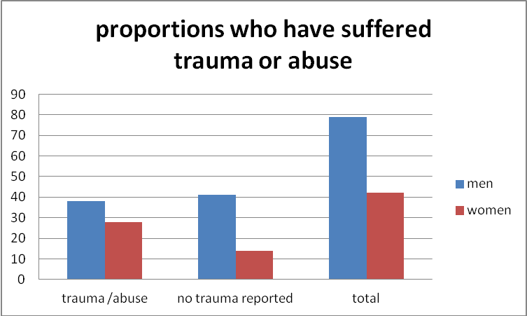

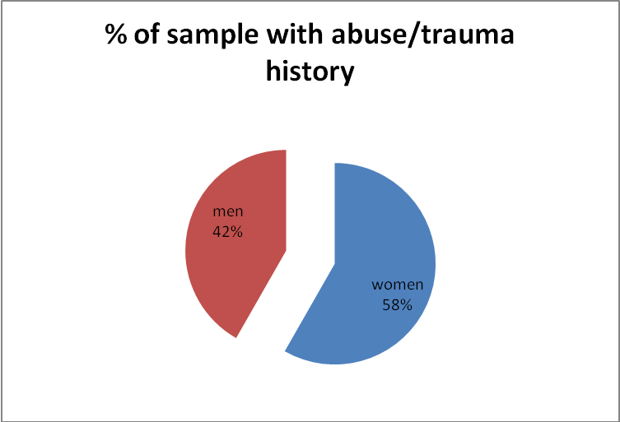
 |  | total | abused
men |  | 79 | 38
women |  | 42 | 28
 |  | 121 | 66

.

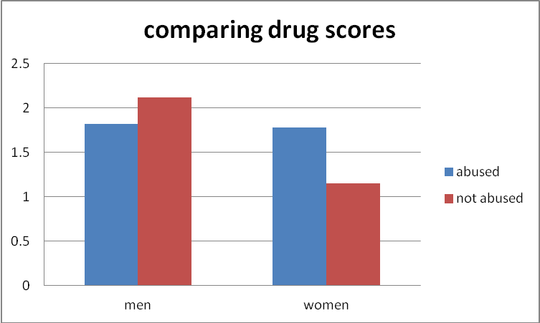
The average drug scores for the whole sample indicate an increased effect for women compared to men regarding impact of trauma and abuse on drug use.
Regarding alcohol, a similar increase is see among men
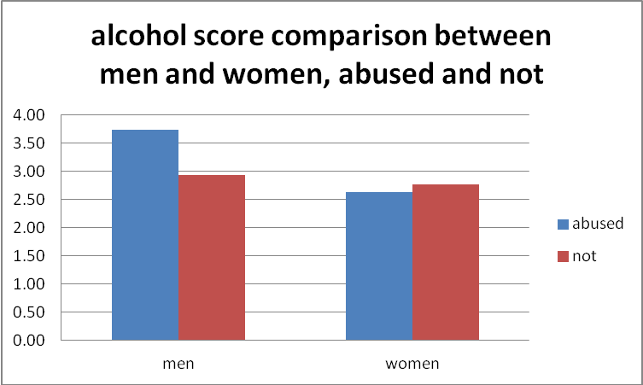
abused | 66 | drug score | alc score | su tier | cx need
men | 38 | 1.82 | 3.74 | 1.91 | 3.05
women | 28 | 1.78 | 2.63 | 1.87 | 3.48
average |  | 1.80 | 3.23 | 1.86 | 3.18
not abused | 55
men | 42 | 2.12 | 2.93 | 1.50 | 2.31
women | 13 | 1.15 | 2.77 | 1.76 | 1.76
average |  | 1.89 | 2.89 | 1.70 | 1.89
Given the above data table, it is not surprising that the concept of substance use treatment tiers has fallen out of favour. Rating the complexity of needs it is clear even without looking at the charts below that OASYS scores or a combined rating of complexity of need gives a much more distinctive picture than su treatment tier ratings
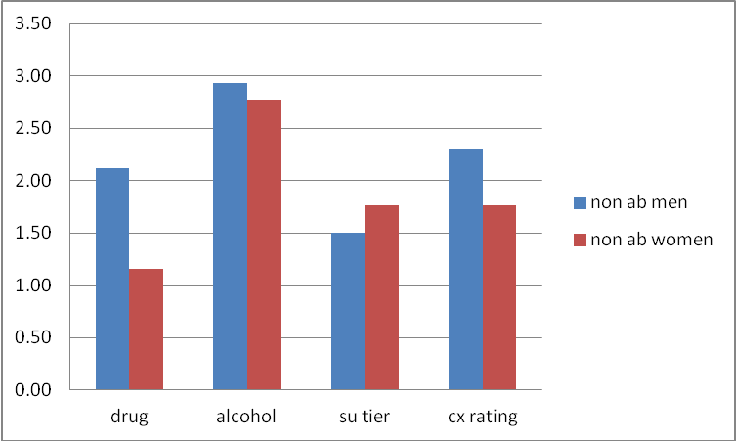
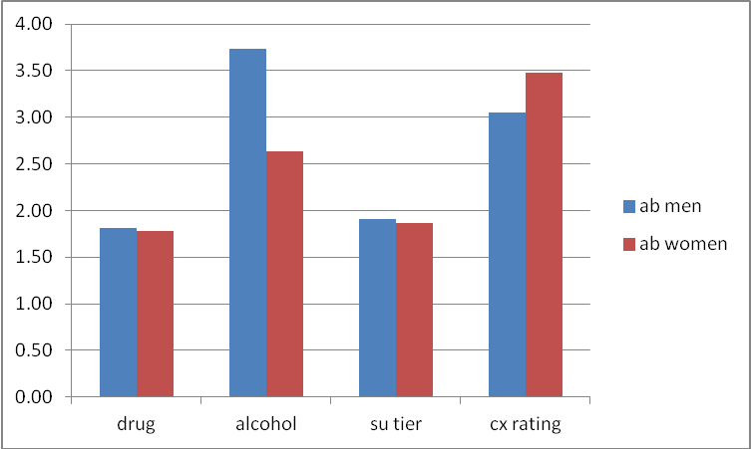
Even so, on average the average treatment tier increase is over 25% for men who have history of abuse compared to those who do not have this history, suggesting that a substantially increased level of treatment resources is needed to address this factor.
These effects are more clearly apparent in cases where the OASYS drug score or OASYS alcohol score is greater than 4, which would usually be taken by offender management to indicate that specific interventions are needed to address drug or alcohol issues in relation to offending behaviour:

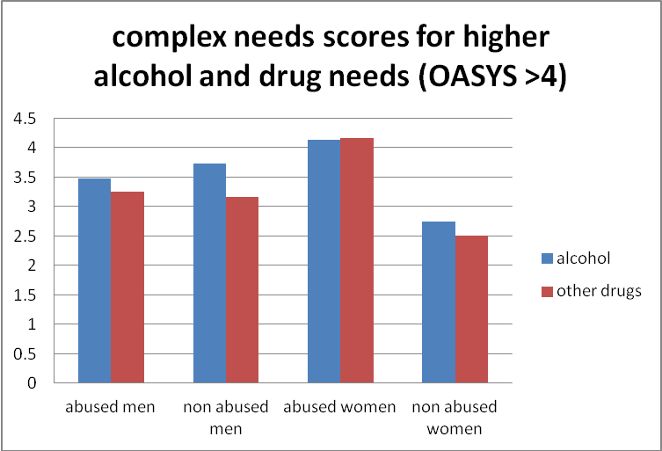
The complex needs score represents how many needs the client has out of those needs covered by the study (from 0-7) with offending behaviour assumed as a baseline (i.e. one could increase all the scores by 1 to cater for the need to address offending behaviour)
In this chart we can see clearly that women with a history of trauma and abuse have a much higher complex need score than their counterparts who do not show this factor in their history. Treatment needs may well differ substantially between these groups of women.

However, one can also see clearly that the level of complex needs for men with a higher intensity of substance use along with offending behaviour is very similar to that for abused women. A history of trauma and abuse in men with substance use and offending behaviour will on average increase level of need and suggests some attention to this factor, but the overall level of need for men is quite high for both groups, suggesting that more attention should be given to complex needs for men in general.
complex needs score for higher alcohol and other drug use
 | abused men | non abused men | abused women | non abused women
alcohol | 3.47 | 3.73 | 4.13 | 2.75
other drugs | 3.25 | 3.17 | 4.16 | 2.5

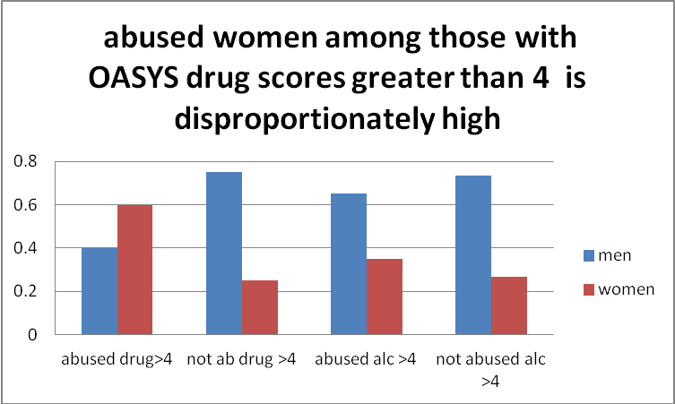

This chart extracts the OASYS drug and alcohol scores greater than 4 (on a scale of 0 to 12) and compares them between men and women, and between those with history of trauma or abuse, and those without that history.
Here we can see the elevated prevalence of more severe drug use among women in response to history of trauma and abuse, compared to women without that history

One way to appreciate the relationship of experiences of trauma, particularly abuse, to complex needs is to stack all the data up according to numbers of different needs.
In the chart below we see that experiences of trauma are related to higher needs peaks than non trauma cases
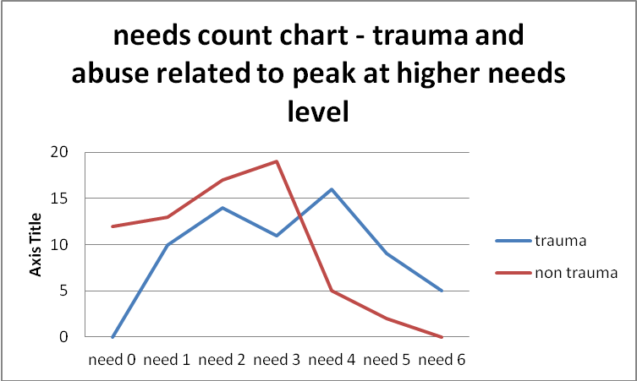

Bearing in mind that all the cases have a common need regarding offending, we can see that those with no additional needs are zero for non trauma cases. i.e. all the cases with no additional needs remained within the non trauma or abuse group.
For those with one additional need the numbers were similar for trauma and non trauma. Additional needs peaked for non trauma at 3 additional needs and fell off sharply thereafter.

In contrast the majority of those with a needs count of 4, 5 and 6 fell within the trauma group. Indeed at the maximum need, all the clients had trauma/abuse in their history.

Eleanor Levy

